

Doing the Right Thing

Management Development Series



New York State Department of Taxation and Finance

Class Objectives

When presented with a dilemma. **LEO** can guide you. Just ask yourself:

**NYS Code of Ethics**

* **Don’t use your state position to obtain anything to which you are not entitled.**
* **Don’t allow any outside interests to improperly influence your official actions.**
* **Don’t do anything that could make it look as if you are doing one of the first two things.**

**‘Hotspots’ that managers should monitor since they may present a conflict of interest for Tax Department employees:**

**The Department’s Mission is:**

To efficiently collect tax revenues in support of State services and programs while acting with integrity and fairness in the administration of the tax laws of New York State.

*Be honest to those who are honest, and be also honest to those who are not honest. Thus honesty is attained.*

*-*Lao Tzu

**Ethical Principles**

* Honesty: ______________________________________________

______________________________________________________

* Integrity: ______________________________________________

______________________________________________________

* Promise Keeping: _______________________________________

______________________________________________________

* Loyalty: _______________________________________________

______________________________________________________

* Fairness: ______________________________________________

______________________________________________________

* Caring and Concern for Others: ____________________________

______________________________________________________

* Respect for Others: ______________________________________

______________________________________________________

* Civic Duty: _____________________________________________

______________________________________________________

* Pursuit of Excellence: ____________________________________

______________________________________________________

* Personal Accountability: __________________________________

______________________________________________________

*Real integrity is doing the right thing, knowing that nobody's going to know whether you did it or not.*

-Oprah Winfrey

**Right vs. Right -**

**Facing tough choices**

When we are faced with a clear-cut “wrong”, this is not really a dilemma.

Upon sober reflection, most of us can differentiate between right and wrong and there is no real moral struggle. The struggle results from decisions we must make when the choices are between two “rights”.

C:\Users\TG40982\AppData\Local\Microsoft\Windows\Temporary Internet Files\Content.IE5\W1Z5PRP6\MC910217581[1].wmf**Right vs. Right Dilemmas**

**Truth vs. Loyalty**

Would you tell a lie to save a life?

Would you compromise your personal integrity to help a friend?

**Individual vs. Community**

Should the rights of the individual outweigh the rights of the community or vice versa?

**Short Term vs. Long Term**

Save for retirement or buy a needed new car?

**Justice vs. Mercy**

Justice = follow the law and principles, regardless of the circumstances. Mercy = compassion.

Consideration of individual circumstances.

Dilemma Exercises

**Office consolidation**

You are a manager in a District Office. A subordinate comes to you and asks about a rumor she has heard about some office consolidations. You are aware that there is indeed a plan to consolidate some offices. You are not supposed to share this information while the plan is still evolving. Your subordinate employee is very concerned, as she has elderly parents living near her who are not well. The employee is worried about her job and her family commitments. This employee has been hardworking and loyal, and has always supported your management initiatives.

What would you do?

|  |
| --- |
|  |
|  |
|  |
|  |
|  |
|  |
|  |
|  |
|  |

What are the Right vs. Right Principles that helped you come to your decision?

|  |
| --- |
|  |
|  |
|  |
|  |

**New Employee**

A new employee appears to have great potential. She is a hard worker, careful and likable. One day, she approaches her supervisor with a question and sits down at her desk. She sees on her supervisor’s desktop that she is browsing wage reporting. She notices that the account her supervisor is looking up the same last name. Her supervisor had told her when she first met her that she has a daughter who has some health issues. She has also heard through the grapevine that there are a lot of medical expenses and that her ex-husband has stopped paying child support. The new employee, having recently taken Annual Disclosure and Security Awareness training, knows this needs to be reported and comes to you with what she has seen. You are a supervisor of another team in this unit. The supervisor in question is a long-time friend and coworker who you know is going through a tough time.

What would you do?

|  |
| --- |
|  |
|  |
|  |
|  |
|  |
|  |
|  |
|  |
|  |

What are the Right vs. Right Principles that helped you come to your decision?

|  |
| --- |
|  |
|  |
|  |
|  |
|  |
|  |

**Taxpayer Information**

As a sales tax employee, you receive a phone call from a former employee you use to work with. One of his clients has received an assessment for corporation tax. The client does not know what the assessment is for. The client has tried phoning the call center number but was unable to learn anything so he contacted his representative. You determine that this representative has a POA on file for this corporation. There is no corporation tax audit section in your District Office.

What would you do?

|  |
| --- |
|  |
|  |
|  |
|  |
|  |

What are the Right vs. Right Principles that helped you come to your decision?

|  |
| --- |
|  |
|  |
|  |
|  |
|  |

Would your answer change if the request came from a represenative you have dealt with in the past on a different Audit? (Again assuming that he had a valid power of attorney for the corporation.)

|  |
| --- |
|  |
|  |

**Group Think**

Groupthink is a process used by groups of people to make and justify decisions. These decisions are often faulty and lead to fiascoes.



In 1972, psychologist Irving Janis defined groupthink as “a mode of thinking that people engage in when they are deeply involved in a cohesive in-group, when the members’ strivings for unanimity override their motivation to realistically appraise alternative courses of action”

**Eight Main Symptoms of Group Think**

*Janis, I. L. & Mann, L. (1977). Decision making: A psychological analysis of conflict, choice, and commitment. New York: Free Press.)*

1. Illusion of Invulnerability: Members ignore obvious danger, take extreme risk, and are overly optimistic.

Consequence: ____________________________________________________

2. Collective Rationalization: Members discredit and explain away warning contrary to group thinking.

Consequence: ____________________________________________________

3. Illusion of Morality: Members believe their decisions are morally correct, ignoring the ethical consequences of their decisions.

Consequence: ____________________________________________________

4. Excessive Stereotyping: The group constructs negative stereotypes of rivals outside the group.

Consequence: ____________________________________________________

5. Pressure for Conformity: Members pressure any in the group who express arguments against the group's stereotypes, illusions, or commitments, viewing such opposition as disloyalty.

Consequence: ____________________________________________________

6. Self-Censorship: Members withhold their dissenting views and counter-arguments.

Consequence: ____________________________________________________

7. Illusion of Unanimity: Members perceive falsely that everyone agrees with the group's decision; silence is seen as consent.

Consequence: ____________________________________________________

8. Mindguards: Some members appoint themselves to the role of protecting the group from adverse information that might threaten group complacency.

Consequence: ____________________________________________________

**Avoiding Group Think**

1. The group should be made aware of the causes and consequences of group think.

2. The leader should be neutral when assigning a decision-making task to a group, initially withholding all preferences and expectations. This practice will be especially effective if the leader consistently encourages an atmosphere of open inquiry.

3. The leader should give high priority to airing objections and doubts, and be accepting of constructive criticism.

4. Groups should always consider unpopular alternatives, assigning the role of devil's advocate to several strong members of the group.

5. Sometimes it is useful to divide the group into two separate deliberative bodies as feasibilities are evaluated.

6. Spend a sizable amount of time surveying all warning signals from rival group and organizations.

7. After reaching a preliminary consensus on a decision, all residual doubts should be expressed and the matter reconsidered.

8. Outside experts should be included in vital decision making.

9. Tentative decisions should be discussed with trusted colleagues not in the decision-making group.

10. The organization should routinely follow the administrative practice of establishing several independent decision-making groups to work on the same critical issue or policy.

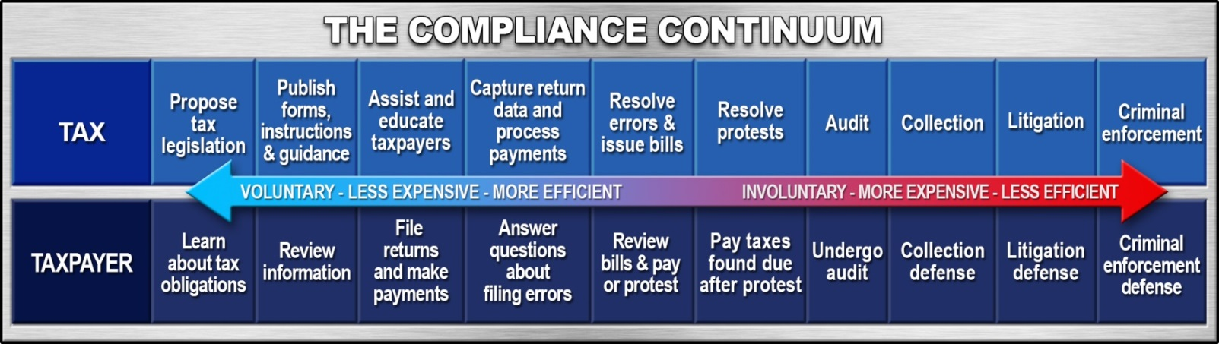

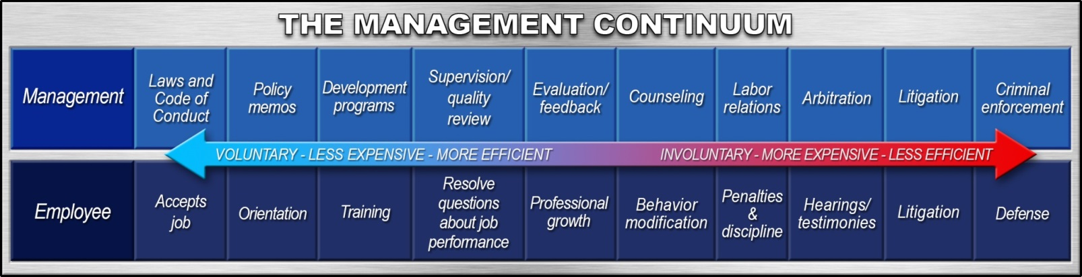

**The Department’s Mission is:**

To efficiently collect tax revenues in support of State services and programs while acting with integrity and fairness in the administration of the tax laws of New York State.

**Appendix:**

1. **Action Plan**
2. **Department’s Mission**
3. **Plain Language Version of New York State Ethics Law**
4. **How to Report Misconduct:**

**http://taxportal/ethics/Pages/rptms.aspx**

**ACTION PLAN**

Directions:

① Based on the skills you learned today, list at least 3 actions you will immediately incorporate into your job.

② Successful training is based on using the skills you learned and getting the necessary support from your supervisor/manager. List how your supervisor/manager can support you in implementing your action plan.

③ Commit to a time frame to meet with your supervisor/manager and discuss your action plan.

|  |  |  |  |
| --- | --- | --- | --- |
| **Class Name:** | **Doing the Right Thing** | **Date:** |  |

① **Actions I will immediately incorporate into my job:**

|  |
| --- |
| Think about LEO when making decisions.  Avoid Groupthink |
|  | |
|  | |
|  | |

② **I will meet with my supervisor/manager and discuss the following:**

|  |
| --- |
| How can I create an ethical environment? |
|  |
|  |
|  |
|  |

③ **I will meet with my supervisor/manager and discuss this action plan by:**

|  |
| --- |
|  |

**The Department’s Mission is:**

To efficiently collect tax revenues in support of State services and programs while acting with integrity and fairness in the administration of the tax laws of New York State.



**A Plain Language Version of New York State Ethics Law**

If you work for a State department, a public authority, public benefit corporation or commission at least one of whose members is appointed by the Governor, you should know about these key parts of the Public Officers Law ("POL"). The actual law is more complex, and there are some exceptions, so if you have questions, contact the New York State Joint Commission on Public Ethics at 518.408.3976.

Keep in mind that the Tax Department’s Code of Conduct has stricter rules regarding gifts and outside employment. Contact the Ethics Officer for advice and guidance at Ethics/NYSTAX.

1. **Gifts Over $15.** You may not receive any gift (including money, food, travel, tickets) worth $15 or more in circumstances where the public could reasonably think it is meant to influence or reward you for your official action. If the donor does business with your agency, you probably cannot take a gift of $15 or more. POL §73(5)
2. **Gifts Under $15**. You may not receive a gift of any amount if it is in substantial conflict with your public duties, for example, a gift of more than nominal value from someone whose public business comes before you. POL §74(2)
3. **Matters Before State Agencies**. Except in your official duties, in a ministerial matter, or for a union, you may not be paid for any appearance or services in a matter before a State agency in connection with: (a) the purchase, sale, rental or lease of real property, goods or services or a contract; (b) rate-making; (c) the adoption or repeal of a regulation; (d) loans or grants; (e) licensing; or (f) public utility franchises. POL §73(7)
4. **Communications With State Agencies**. If your private associate, firm or company is appearing or rendering services before a State agency in connection with: (a) the purchase, sale, rental or lease of real property, goods or services or a contract; (b) rate-making; (c) the adoption or repeal of a regulation; (d) loans or grants; (e) licensing; or (f) public utility franchises, then you may not orally communicate about the merits of the matter with anyone at the agency concerned with the matter. POL §73(12)
5. **Sales to State Agencies**. Neither you, your firm, nor a corporation of which you control at least 10% of the stock, may sell goods or services worth more than S25 to a State agency unless it is pursuant to a contract or award let after public notice and competitive bidding. POL §73(4)
6. **Sales to Regulated Entities**. Neither you, your firm nor a corporation controlled by you may sell goods or services to any person, firm or company which is licensed by or whose rates are fixed by your agency. POL §74(3)(i)
7. **Conflicts of Interest**. You may not have any interest or engage in any business or transaction or professional activity or incur any obligation of any nature which is in substantial conflict with the proper discharge of your public duties. POL §74(2)
8. **Confidential Information**. You may not disclose confidential State information or use it for your personal interests. POL §74(3)(b)(c)
9. **Misuse of Office.** You may not use your official position to secure unwarranted privileges or exemptions for yourself or others. POL §74(3)(d)
10. **Appearance of Impropriety**. You may not do anything that would give the public a reasonable basis to think that anyone can improperly influence you in your official duties by reason of kin­ship, rank, position or influence. POL §74(3)(f)
11. **Violation of Trust**. You must not raise public suspicion that you are acting in violation of your public trust. POL 574(3)(h)
12. **Dealing With Yourself or Your Company**. You may not engage in any transaction as an agent for the State with any business entity in which you have a financial interest that might tend to conflict with the proper discharge of your official duties. Instead you should recuse yourself and ask someone else to do the State task. POL §74(3)(e)
13. **Investments**. You may not make personal investments in enterprises which might be directly involved in decisions to be made by you. POL §74(3)(g)
14. **Moonlighting**. You should not take a job which would impair your official independence, for example, with a vendor seeking a contract which you must review, or a company seeking a permit on which you must make a recommendation. POL §74(3)(a)
15. **Honoraria and Travel Reimbursement**. You may not accept honoraria or official travel reim­bursement without prior approval by your agency or the Ethics Commission. If the donor does business with your agency, you probably cannot accept such payments. 19 NYCRR §930
16. **Outside Activities**. If you are a paid policymaker, you may not engage in any outside activity for more than $1,000 per year without prior agency approval, or for more than $4,000 per year without prior Ethics Commission approval. 19 NYCRR §932.3
17. **Political Activities**. If you are a policymaker, you may not serve as an officer of any political party or organization, or as a member of any political party committee. 19 NYCRR §932.2
18. **Contingent Fees**. You may not be paid for services where your fee is dependent or contingent on State agency action. POL §73(2)
19. **Court of Claims**. You may not be paid for services in or out of court against the State's interest in the Court of Claims. POL §73(3)
20. **Post-Employment Two-Year Ban**. For two years after you leave public employment, you may not appear before your former State agency or receive pay for services in a matter pending before it. Your former agency may have stricter rules. POL §73(8)(a)(i)
21. **Post-Employment Lifetime Ban**. After you leave public employment, you may not appear before any State agency or receive pay for services in a matter on which you personally worked for the State. Your former agency may have stricter rules. POL §73(8)(a)(ii)
22. **Financial Disclosure**. If your agency has designated you as a policymaker, or if you earn over the SG-24 rate (currently $88,256 per year) and have not received an exemption, then you must file an annual financial disclosure statement with the Ethics Commission by May 15. If you begin public employment after May 15 o any year and must file, you must do so within thirty days of joining State service. POL §73-a(2)

|  |  |
| --- | --- |
| **How to report misconduct** |  |
|  |  |

|  |
| --- |
| Page Content  New York State [law](http://public.leginfo.state.ny.us/LAWSSEAF.cgi?QUERYTYPE=LAWS+&QUERYDATA=$$EXC55$$@TXEXC055+&LIST=LAW+&BROWSER=EXPLORER+&TOKEN=38608893+&TARGET=VIEW) and our [Code of Conduct](http://taxportal/OHRM/hradvisor/Pages/code_conduct.aspx) require department employees to report:   * criminal activity (including corruption and fraud), * conflicts of interest, or * abuse of one’s position as a state employee.   Employees must report misconduct to both the New York State Inspector General (NYSIG) and the Tax Department's Office of Internal Affairs (OIA).  **Online form:** You can notify both offices at once by completing and submitting our [online Report of Misconduct form](http://taxportal/_layouts/FormServer.aspx?XsnLocation=/FormServerTemplates/ReportOfMisconductForms.xsn&ClientInstalled=true&Source=http://taxportal/ethics/Pages/rptms.aspx&DefaultItemOpen=1). This will automatically send the form simultaneously to NYSIG and OIA.   * If you prefer, you may contact each office separately. Both offices accept anonymous complaints. Please contact OIA or NYSIG if you have questions about this reporting process. * When you report improper governmental action to the State Inspector General, you are protected from dismissal, discipline, or other adverse personnel actions.   **New York State Office of the Inspector General (NYSIG)** [NYSIG website](http://www.ig.ny.gov/contact) 1-800-367-4448   **Office of Internal Affairs (OIA)** [OIA’s intranet page](http://taxportal/OIA/Pages/default.aspx)  518-451-1566; 451-1598  Building 8 Room 938 W A Harriman Campus Albany NY 12227  In addition to the Office of Internal Affairs, our Ethics Officer and the Labor Relations Bureau are available to assist with internal matters:   * Our **Ethics Officer** offers advice on whether employee actions comply with the Public Officers Law and/or the Joint Commission on Public Ethics (JCOPE) guidelines, including ones about accepting gifts, conflicts of interest, or attendance at conferences. Email questions to the [Ethics Officer](mailto:Ethics/NYSTAX) or call (518) 457-2988. * Our **Labor Relations Bureau** helps supervisors deal with employees with behavioral or performance deficiencies, such as those who may require counseling or discipline for time and attendance violations. Contact the [Labor Relations Bureau](http://taxportal/OHRM/labor/Pages/default.aspx) by calling (518) 457-3110. |

Additional Notes:

|  |
| --- |
|  |
|  |
|  |
|  |
|  |
|  |
|  |
|  |
|  |
|  |
|  |
|  |
|  |
|  |
|  |
|  |
|  |
|  |
|  |
|  |
|  |
|  |
|  |